**Ram Gopal Varma Venkata Sai Akhil**

**Mohit Sanghai**

**INFO 6205 Program Structures and Algorithms**

**Final Project**

**Task:**

A Report which summarizes your overall findings and recommendations—and shows, graphically, your main conclusions

**Observation**:

This Report aimed to evaluate the performance of various sorting algorithms used for natural language. Through implementations of Husky sort, Tim sort, Dual-pivot quicksort, MSD radix sort, and three-way radix quicksort, we sorted data types of any type including strings. To conclude the above sorting implementations, we benchmarked them with 1 million Chinese words according to pinyin. We also benchmarked them with other natural languages such as Telugu and English. Several unit tests were added to cover each implementation of the algorithm. Husky sort has been observed to outperform all other algorithms when sorting a million words. We had gone through a few relevant technical papers on the subject of sorting.

**Conclusion:**

We benchmarked the above sorting algorithms for randomized input of 1 million Chinese words. We sorted them as per the pinyin order. The results are as follows -

|  |  |
| --- | --- |
| **Sort Algorithm** | **Time (in sec)** |
| Husky sort | 0.7 |
| Tim sort | 5 |
| Dual Pivot Quicksort | 7 |
| LSD | 21 |
| MSD | 71 |
| Three-way Radix Sort | 11 |

It shows that Husky sort is the best sorting algorithm to sort strings.

**Evidence:**

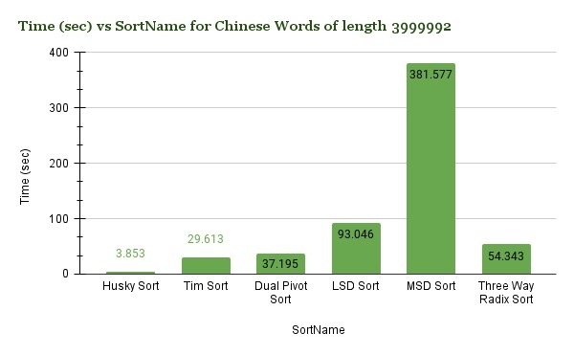

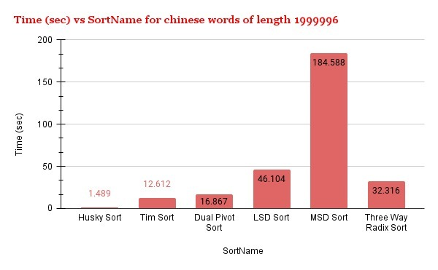

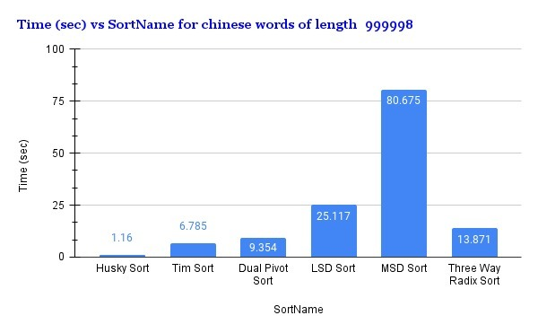

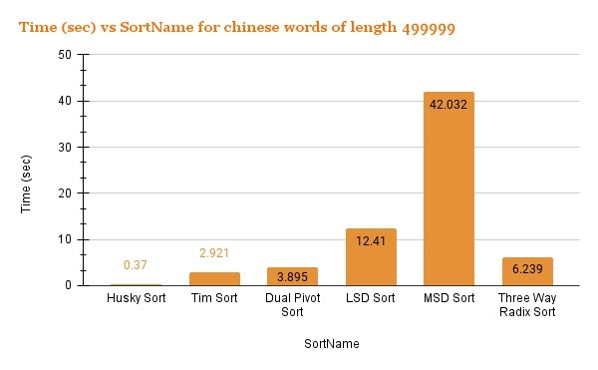

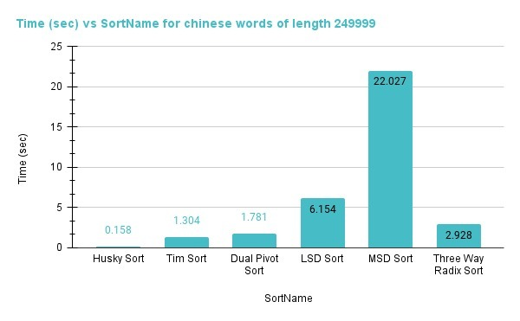

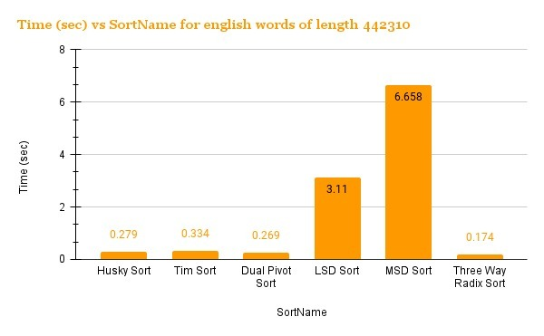

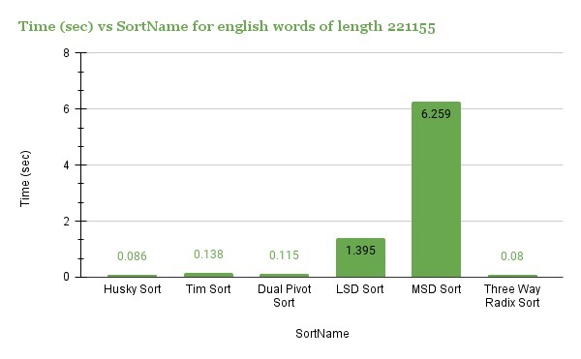

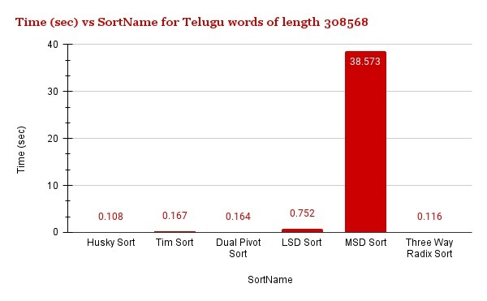

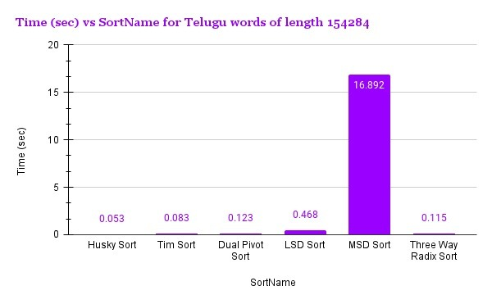

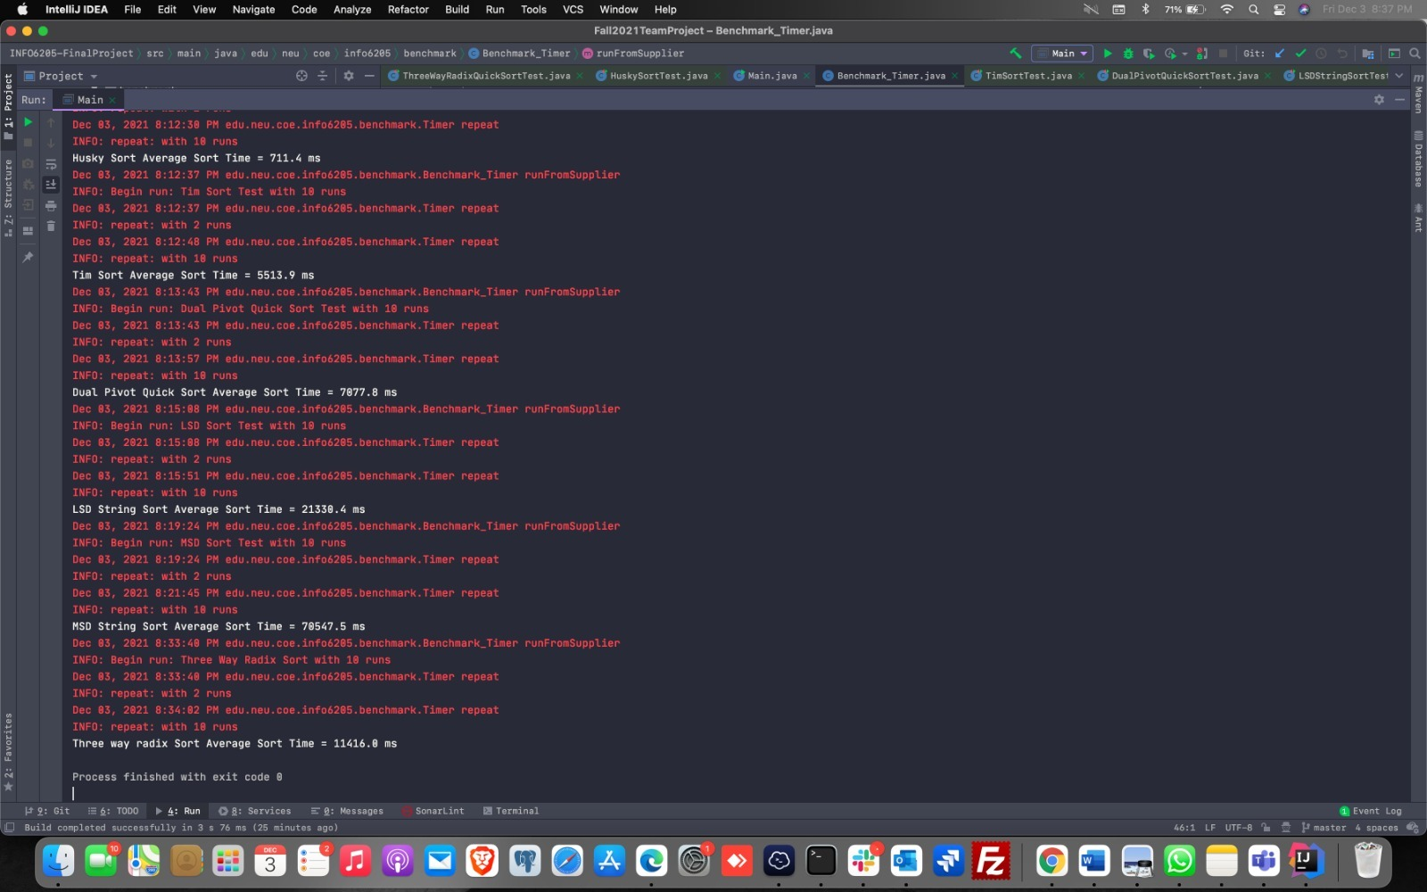

**Testcases:**

